

Capstone Project Report
Report 2 – Project Management Plan

– Cantho, Jan 2026 –
I. Project Report 3
1. Status Report 3
2. Team Involvements 3
3. Issues/Suggestions 3
II. Project Management Plan 4
1. Overview 4
1.1 WBS & Estimation 4
1.2 Project Risks 6
2. Management Approach 8
2.1 Project Process 8
a. Key Characteristics of Scrum 8
b. Advantages of Scrum 9
c. Disadvantages of Scrum 9
d. Why Use Scrum for this Project? 9
2.2 Quality Management 10
a. Defect Prevention 10
b. Reviewing (Code Review) 10
c. Unit Testing 10
d. System Testing 10
2.3 Training Plan 11
3. Master Schedule 11
4. Project Organization 13
4.1 Team & Structures 13
4.2 Roles & Responsibilities 13
5. Project Communication 15
5.1 Communication Plan 15
5.2 External Interface 16
a. FU Contacts 16
b. Customer Contacts 17
6. Configuration Management 17
6.1 Tools & Infrastructures 17
6.2 Document Management 17
6.3 Source Code Management 19

I. Project Report

1. Status Report
# | Work Item | Status | Notes (Work Item in Details)
1 | Project documentation and planning | Completed | The team is preparing and refining the main project documents, including the Project Management Plan, use case description, business rule sheet, and supporting diagrams.
2 | Technology research and validation | Completed | The team completed research on the selected technology stack, including React, NestJS, PostgreSQL, Supabase, Docker, Tailwind CSS, Redis, GitHub Actions, and PayPal integration for the InterDev platform.

2. Team Involvements
# | Task | Member | Notes (Task Details, etc.)
1 | Project coordination and report integration | SonNT | Team leader. Responsible for coordinating progress, consolidating report content, and reviewing the overall structure and consistency of project documentation.
2 | Authentication, KYC, admin, and wizard-related documentation | BaoNG | Prepared and reviewed content related to authentication flows, account management, KYC processing, admin functions, and wizard-question management.
3 | Architecture, dispute/hearing flows, and technical research | BangDC | Contributed to system analysis, dispute and hearing workflows, and research on technical and architectural topics used in the project documents.
4 | Contract, specification, and payment-related analysis | AnNP | Prepared documentation and analysis for contract workflows, specification approval flows, subscription/payment features, wallet, and financial interactions.
5 | Project workspace, milestone, and board-flow documentation | AnPTT | Worked on documentation for project execution features such as current projects, milestones, kanban board actions, progress tracking, and related workspace interactions.

3. Issues/Suggestions
# | Issue | Status | Notes (Solution, Suggestion, etc.)
1 | Selecting and validating the most suitable technology stack | Completed | The team compared candidate technologies and finalized a stack centered on React, NestJS, PostgreSQL, Supabase, Docker, and PayPal after evaluating feasibility and project scope.

II. Project Management Plan

1. Overview

1.1 WBS & Estimation
# | WBS Item | Complexity | Est. Effort (man-days)
1 | Document |  | 44
1.1 | Report 1: Project Introduction | Simple | 4
1.2 | Report 2: Project Management Plan | Medium | 7
1.3 | Report 3: Software Requirement Specification (SRS) | Complex | 10
1.4 | Report 4: Software Design Document (SDD) | Complex | 10
1.5 | Report 5: Test Documentation | Medium | 7
1.6 | Report 6: Software User Guides | Simple | 3
1.7 | Report 7: Final Project Report | Simple | 3
2 | Development Features |  | 126
2.1 | Auth & Identity (FE-01, FE-02) |  | 14
2.1.1 | Authentication (Login/Register/SSO) | Medium | 5
2.1.2 | Manage Profile & Recover Password | Simple | 3
2.1.3 | KYC Verification & Identity Mgmt | Medium | 6
2.2 | Brokerage & Matching (FE-03 -> FE-06) |  | 22
2.2.1 | Broker Application & Vetting | Simple | 3
2.2.2 | Client Guided Input Wizard | Complex | 7
2.2.3 | Requirement Standardization (Draft to Spec) | Medium | 5
2.2.4 | Matching Logic & Freelancer Selection | Complex | 7
2.3 | Contract & Financial Core (FE-07, FE-14, FE-15) |  | 25
2.3.1 | E-Contract Generation & Digital Sign | Medium | 6
2.3.2 | Virtual Escrow (Deposit/Lock Funds) | Complex | 8
2.3.3 | Wallet Management & Withdrawals | Complex | 7
2.3.4 | Automatic Fee Calculation Logic | Medium | 4
2.4 | Project Workspace & Execution (FE-08 -> FE-13) |  | 34
2.4.1 | Project Dashboard & Team Mgmt | Medium | 5
2.4.2 | Task Management (Kanban Board) | Complex | 8
2.4.3 | Real-time Communication (Chat + Attachments) | Complex | 10
2.4.4 | Milestone Submission & Evidence | Medium | 4
2.4.5 | Multi-step Acceptance & Funds Release | Complex | 7
2.4.6 | Change Request Management | Medium | 5
2.5 | Admin & Governance (FE-16 -> FE-20) |  | 31
2.5.1 | Rating & Trust Score Engine | Complex | 7
2.5.2 | Dispute Resolution System | Complex | 8
2.5.3 | Notification System (In-app/Email) | Medium | 5
2.5.4 | User Dashboard & Portfolio (Freelancer/Client) | Medium | 6
2.5.5 | Admin Dashboard & System Config | Medium | 5
3 | Testing |  | 30
3.1 | Unit Testing | Medium | 15
3.2 | System Integration Testing | Complex | 15
4 | Project Management |  | 10
4.1 | Deployment & CI/CD Setup | Medium | 5
4.2 | Bug Fixing & Polish | Medium | 5

Total Estimated Effort (man-days): 210

1.2 Project Risks
# | Risk Description | Impact | Possibility | Response Plans
1 | Member Dropout | High | Low | - Redistribute tasks among remaining members.  - Require members to document code daily so others can take over easily.
2 | Source Code Loss / Git Conflicts | Medium | High | - Enforce strict Git workflow (Feature Branch).  - Backup source code daily to a secondary storage (Drive/OneDrive).  - Review code before merging to main.
3 | Technical Complexity Blockers | High | Medium | - Research & Development (R&D) on critical modules (Socket.io, Payment Gateway) early in the project.  - Consult mentors or technical experts immediately if stuck for more than 2 days.
4 | Scope Creep / Requirement Change | Medium | High | - Freeze requirements after the SRS phase.  - Any new change must go through the formal "Change Request" process (evaluate impact on timeline before accepting).
5 | Testing Environment Failure | Medium | Medium | - Prepare multiple test accounts (Client, Broker, Freelancer) with pre-filled data.  - Use Mock Data for payment testing instead of real money initially.
6 | Out of Budget (Cloud/Hosting) | Medium | Medium | - Use Free Tier services (Vercel, MongoDB Atlas, Render) for development.  - Pool funds from team members for necessary paid services if free tiers are exceeded.
7 | Device/Hardware Failure | High | Low | - Member switches to a backup device (borrowed/labs).  - Team supports the affected member with their tasks until the device is fixed.

2. Management Approach

2.1 Project Process
For this project, the team will adopt Scrum, an Agile framework that emphasizes iterative progress, collaboration, and adaptability. Given the complexity of the platform (involving multiple roles: Client, Broker, Freelancer, and critical financial features), Scrum allows the team to deliver functional components in short cycles called Sprints (lasting 2 weeks).
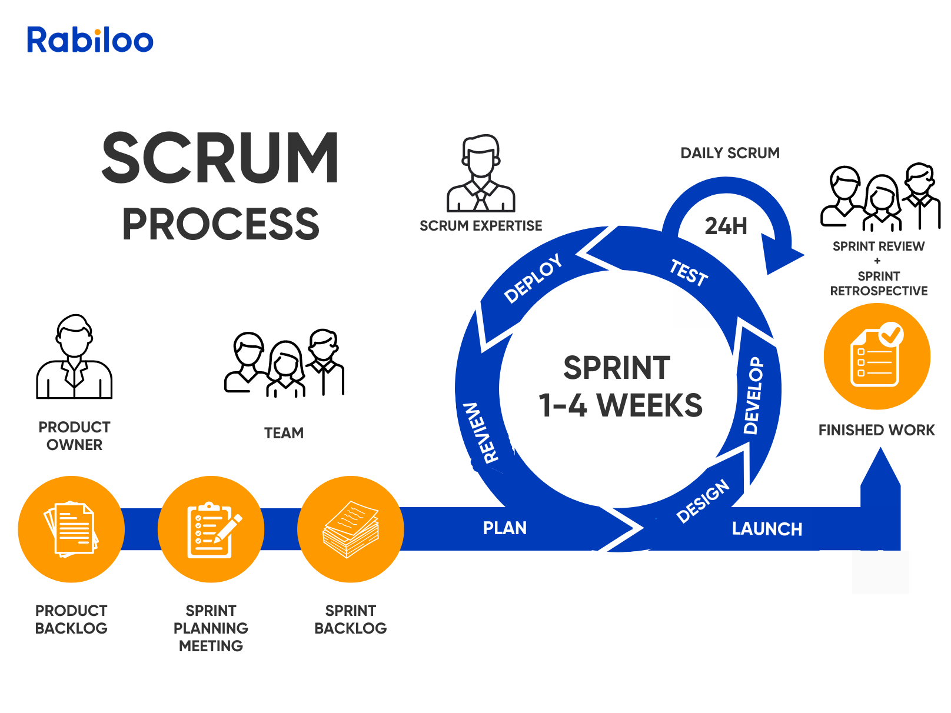
Figure 1. Scrum Process

a. Key Characteristics of Scrum
Scrum relies on three pillars: Transparency, Inspection, and Adaptation. The implementation includes:
- Roles:
  - Product Owner: Defines the product vision and manages the Product Backlog (prioritizing features like Escrow, Chat, etc.).
  - Scrum Master: Ensures the team follows Scrum principles and removes any blockers during development.
  - Development Team: Cross-functional members responsible for designing, coding (FE/BE), and testing the increments.
- Artifacts:
  - Product Backlog: A master list of all desired features (FE-01 to FE-20).
  - Sprint Backlog: Specific tasks selected for the current Sprint.
  - Increment: The usable software version produced at the end of each Sprint.
- Events:
  - Sprint Planning: Defining the "Sprint Goal" and selecting tasks.
  - Daily Scrum: A 15-minute stand-up to sync progress.
  - Sprint Review: Demoing the new features to stakeholders/mentors.
  - Sprint Retrospective: Discussing what went well and what needs improvement.

b. Advantages of Scrum
- Flexibility: Easily adapts to changes in requirements (e.g., modifying the payment flow or broker logic).
- Early Defect Detection: Testing is done continuously within sprints, not just at the end.
- Transparency: Stakeholders can see progress via the Sprint Review.

c. Disadvantages of Scrum
- Scope Creep: Without a strict Product Owner, features can be added endlessly.
- Requires Discipline: Team members must be committed to daily updates and strict time-boxing.

d. Why Use Scrum for this Project?
- Complex Logic Management: The project involves a complex 3-way interaction (Client-Broker-Freelancer). Scrum allows us to build and test the core flow (Happy Case) first, then add edge cases later.
- Risk Mitigation: By delivering small increments (e.g., Authentication first, then Profile, then Chat), we minimize the risk of "Big Bang" integration failures at the end of the semester.
- Regular Feedback: The semester timeline requires regular checkpoints with the supervisor; Scrum’s "Sprint Review" aligns perfectly with these academic milestones.

2.2 Quality Management
To ensure the final product meets the high standards required for a transaction-based platform, we will implement a multi-layered quality assurance strategy.

a. Defect Prevention
Instead of just finding bugs, we aim to prevent them from occurring:
- Coding Standards: Enforcing strict coding conventions (using Linter/Prettier) to keep the codebase clean and consistent.
- Design First: Before coding complex modules (like the Escrow System), the team will create flowcharts and sequence diagrams to catch logic errors early.
- Pair Programming: For critical features, two members will work together on one machine to review logic in real-time.

b. Reviewing (Code Review)
Reviewing is a static testing technique performed before merging code.
- Process: Every Pull Request (PR) must be reviewed by at least one other team member.
- Goal: To detect logic errors, security vulnerabilities (e.g., in wallet management), and ensure code maintainability.
- Tool: We will use GitHub’s Pull Request feature for comments and approval workflows.

c. Unit Testing
- Definition: Unit testing involves verifying the smallest testable parts of the application (functions, methods) in isolation.
- Application: We will focus heavily on Unit Tests for backend logic, especially for:
  - Fee Calculation: Ensuring the 3-way split (Broker/Freelancer/Platform) is mathematically correct.
  - Status Transitions: Verifying that a project status moves correctly (e.g., from "Draft" -> "Pending" -> "In Progress").
- Goal: To ensure that individual "bricks" of the software are solid before assembling them.

d. System Testing
- Definition: Testing the complete, integrated system to evaluate the system's compliance with its specified requirements.
- Application: This acts as the final validation where we test end-to-end user flows (User Journeys).
  - Example: A full cycle test: A Client posts a job -> Broker accepts -> Freelancer submits work -> Client approves -> Money is released.
- Goal: To verify that the system functions correctly as a whole in an environment that mimics production.

2.4 Training Plan
Training Area | Participants | When, Duration | Waiver Criteria
ReactJS | Ngo Thai Son | 16/1/2026, 1 Week | Mandatory
Tailwind CSS | Ngo Thai Son | 16/1/2026, 1 Week | Mandatory
NestJS(Node.js+TypeScript) | Ngo Thai Son | 16/1/2026, 1 Week | Mandatory
Supabase(Cloud storage) | All Member | 16/1/2026, 1 Day | Mandatory

3. Master Schedule
# | Deliverable | Due Date | Deliverable Scope
1 | Project Charter | Week 2 | Project Introduction, Product Background, Business Opportunity, Project Scope & Limitations.
2 | Project Management Plan | Week 3 | WBS, Estimation, Risk Management, Schedule, Team Roles & Responsibilities.
3 | Software Requirement Specification (SRS) | Week 4 | Use Case Diagrams, Functional & Non-functional Requirements, User Stories.
4 | Software Design Document (SDD) | Week 5 | System Architecture, Database Design (ERD), API Specification, UI/UX Mockups.
5 | Sprint 1 Package: Core & Identity | Week 6 | Source Code for: Auth, Profile, KYC Verification (FE-01, FE-02).  Unit Test Reports for Sprint 1.
6 | Sprint 2 Package: Brokerage & Matching | Week 8 | Source Code for: Broker Application, Guided Wizard, Matching Logic (FE-03 to FE-06).  Unit Test Reports for Sprint 2.
7 | Sprint 3 Package: Financial & Contract | Week 10 | Source Code for: E-Contract, Virtual Escrow, Wallet, Fee Calculation (FE-07, FE-14, FE-15).  Unit Test Reports for Sprint 3.
8 | Sprint 4 Package: Execution & Chat | Week 12 | Source Code for: Project Workspace, Kanban, Real-time Chat, Milestone Submission (FE-08 to FE-13).  Unit Test Reports for Sprint 4.
9 | Sprint 5 Package: Admin & Polish | Week 13 | Source Code for: Admin Dashboard, Dispute Resolution, Notifications (FE-16 to FE-20).  Unit Test Reports for Sprint 5.
10 | Software Testing Documentation | Week 13 | Test Plan, Test Scenarios, Test Case Specifications (System Level).
11 | System Testing Report | Week 14 | Execution of System Test Cases, Bug Reports, Bug Fix Verification.
12 | Release Package & User Guide | Week 14 | Deployment Guide, User Manuals (for Client, Broker, Freelancer, Admin).
13 | Final Project Report | Week 15 | Summary of project, lessons learned, future work, conclusion.
14 | Final Package | Week 15 | Complete Source Code (Frontend/Backend/DB scripts), Final Slide, Demo Video.

4. Project Organization

4.1 Team & Structures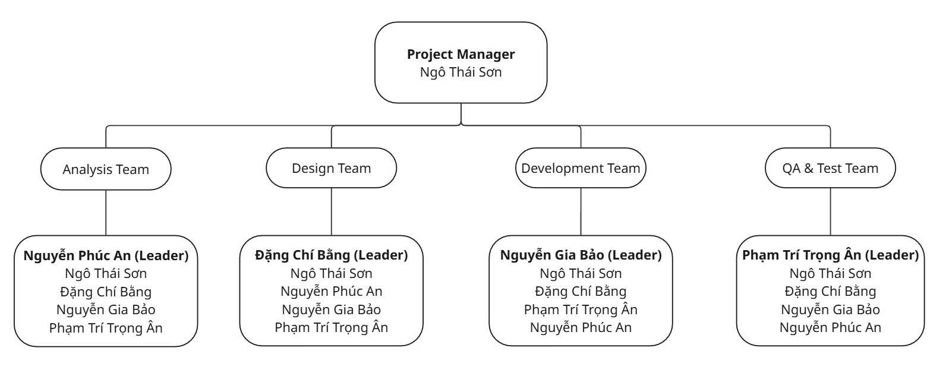
Figure 2. Team and structures

4.2 Roles & Responsibilities

Role | Responsibility
Project Manager | - Define project scope, goals, and deliverables.  - Monitor progress using Scrum framework (manage Sprints).  - Manage risks and resolve conflicts within the team.  - Act as the main point of contact with Supervisors/Mentors.
Analysis Leader | - Lead the requirement gathering phase (Elicitation).  - Responsible for the quality of the SRS (Software Requirement Specification) document.  - Prioritize features in the Product Backlog.  - Clarify business logic (especially for Escrow & Broker flow).
Analysis Member | - Support the Leader in interviewing stakeholders and researching competitors.  - Document User Stories and draw Use Case diagrams.  - assist in writing specific sections of the SRS.
Design Leader | - Define the System Architecture and select the Tech Stack.  - Responsible for the SDD (Software Design Document).  - Design the Database Schema (ERD) and API Specifications.  - Finalize UI/UX design (Figma) before coding begins.
Design Member | - Create wireframes and mockups for assigned modules.  - Write detailed API descriptions (Swagger/Postman).  - Review database relationships to ensure normalization.
Technical Leader | - Set up the development environment (GitHub, CI/CD, Server).  - Establish coding conventions and standards (Linting).  - Lead the Development Team, handle complex logic (e.g., Payment/Socket.io).  - Review Pull Requests (PR) to ensure code quality.
Test Leader | - Create the Test Plan and Test Strategy.  - Manage the bug tracking process (on Jira/Excel).  - Responsible for the final quality before release (Go/No-Go decision).  - Write System Test Cases for critical flows.
Test Member | - Write Unit Tests for their own code.  - Execute System Test Cases assigned by the Test Leader.  - Log bugs with detailed reproduction steps and evidence.

5. Project Communication

5.1 Communication Plan
Communication Item | Who/ Target | Purpose | When, Frequency | Type, Tool, Method(s)
Meeting with supervisor | Team Supervisor - Project Manager (Main) - Team Members | Instruction on the reports, update on project progress. Giving instruction on system design and on the final product | Every Week | Microsoft Team, In-person meeting
Internal Team Meeting (Daily Scrum) | All Team Members | - Sync up on daily tasks  - Quick decision making. | Daily | Google Meet, Discord In-person meeting
Sprint Planning & Review | All Team Members | - Plan tasks for the next Sprint.  - Review completed work (Demo) and Retrospective (Process improvement). | Every 2 Weeks | - In-person Meeting  - Google Meet

5.2 External Interface

a. FU Contacts
Function | Contact Person  (name, position) | Contact address  (email, telephone) | Responsibility
Supervisor | Luong Hoang Huong | HuongLH3@fe.edu.vn  0941666545 | - Provide document template  - Give instruction to project team  - Review deliverables  - Supervise project status

b. Customer Contacts
Function | Contact Person  (name, position) | Contact address  (email, telephone) | Responsibility
Supervisor | Luong Hoang Huong | HuongLH3@fe.edu.vn  0941666545 | - Provide document template  - Give instruction to project team  - Review deliverables  - Supervise project status

6. Configuration Management

6.1 Tools & Infrastructures
Programming languages | TypeScript, JavaScript
Framework | NestJS, ReactJS, Tailwind CSS
API | RESTful API
DBMS | PostgreSQL, Redis
IDEs/Editors | Visual Studio Code
UML tools | PlantUML, draw.io , dbdiagram.io
Version Control | Git/GitHub
Deployment server | Docker, Vercel, Render
Project management tool | Jira

6.2 Document Management
6.2.1 Tools Overview To ensure consistent communication and centralized data storage, the team utilizes the Google Workspace ecosystem:
- Google Docs: Used for drafting official reports (SRS, SDD, Final Report) and meeting minutes. Its real-time collaboration feature allows multiple members to write and review content simultaneously, ensuring everyone is on the same page.
- Google Sheets: Used for dynamic data management, specifically for the Project Schedule (Gantt Chart), Bug Tracking Log, and Test Case Management. Its formula capabilities help in automatically calculating progress and statistics.
- Google Drive: Acts as the central repository for storing all project artifacts (images, diagrams, references), organized by folders corresponding to project phases.
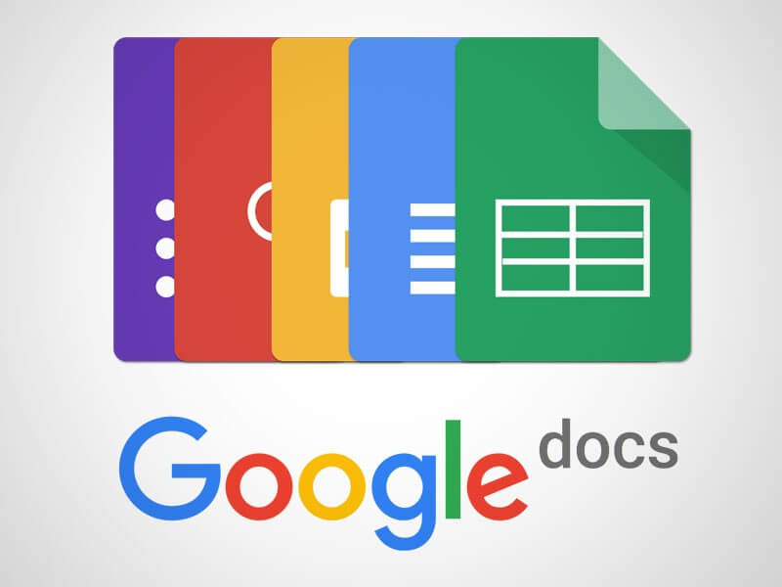
Figure 2. Google Docs
6.2.2 Management Mechanism To maintain document integrity and avoid version conflicts, we apply the following rules:
- Folder Structure: Documents are stored in a hierarchical folder structure on Google Drive:
  - 01_Management (Plans, Schedules, Meeting Notes)
  - 02_Requirement (SRS, User Stories)
  - 03_Design (UI/UX, Database, Architecture)
  - 04_Testing (Test Plans, Test Reports)
- Permission Control:
  - Project Manager: Has Owner access to organize structure and manage final versions.
  - Team Members: Have Editor access to contribute content.
  - Stakeholders (Supervisors): Have Viewer or Commenter access to review without altering content.
- Version Control:
  - We utilize the "Version History" feature in Google Docs/Sheets to track changes and restore previous states if data loss occurs.
  - Naming Convention: [ProjectCode]_[DocType]_[Version]_[Date]
    - Example: FLP_SRS_v1.0_20251120.docx

6.3 Source Code Management
6.3.1 Tools Overview The team uses Git for version control and GitHub as the hosting platform.
- Git: Allows tracking every modification to the code, supporting distributed development.
- GitHub: Provides a collaborative environment with features like Issues (task tracking), Pull Requests (code review), and Actions (basic CI/CD). It serves as the single source of truth for the project's codebase.
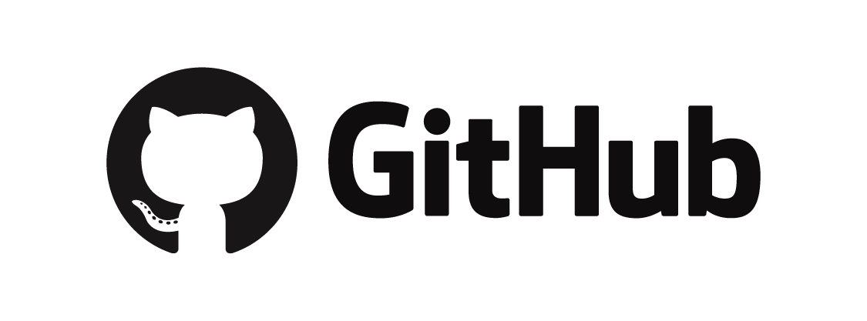
Figure 3. Github
6.3.2 Management Mechanism: Feature Branch Workflow Instead of assigning one branch per member, we adopt the Feature Branch Workflow to isolate development work and ensure the stability of the main codebase.
- Branching Strategy:
  - main (or master): The production-ready branch. This branch contains stable code that has been tested and is ready for demo. Direct commits to main are restricted.
  - feature/[feature-name]: Created from main for developing specific tasks (e.g., feature/FE01-login, feature/FE07-escrow). Developers work exclusively on these branches.
  - hotfix/[bug-name]: Created for urgent fixes on the production code.
- Development Process:
  - Clone & Branch: A member picks a task (e.g., FE-01) and creates a new branch: git checkout -b feature/FE01-login.
  - Commit & Push: The member codes and commits changes regularly with clear messages (e.g., "Update: Add validation for login form").
  - Pull Request (PR): Once the feature is complete, the member pushes the branch to GitHub and creates a Pull Request to merge into main.
  - Code Review: The Technical Leader (or another peer) reviews the PR. They check for coding standards, logic errors, and potential conflicts.
  - Merge: Only after the PR is approved (and conflicts resolved), the code is merged into main.
- Conflict Resolution: If two members modify the same file, a "Merge Conflict" occurs. The involved members and the Technical Leader must discuss to decide which code to keep before finalizing the merge.

https://rabiloo.com/blog/scrum-methodology-a-proven-formula-for-managing-complex-projects
https://docs.google.com/
https://github.com/

